Prompts and Ideology(Use of ChatGPT and copilot)
Can do with cursor to but out of free use
1.
I want to create this:
Write a prompt to generate synthetic e-commerce data (around 5 files).
Write a prompt to ingest that generated data into a SQLite database.
Write an SQL prompt to generate a query that joins multiple tables and produces an output.
First, give ideology and file structure
2.
It gave this folder structure and I prompted to create these.
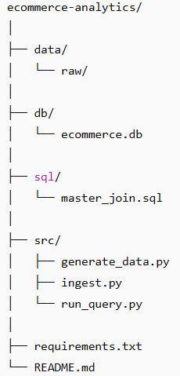
3.
I Divided the workflow in three task .Then created environment and download req.
1.generate_data.py
2.ingest.py
3.run_query.py along with the sql code creation.

4.
prompt: Generate the required code for phase 1 generate_data.py
It generated the code and tested/run the code on terminal
Result: Created the files on database
Pushed this in the repo as main branch which is the basis for the code.

5.
Created a new branch in git from main branch called feature/ingest.py.
Prompt: Generate code for ingest.py
Tested by running the .py file
Now the ingest part is done.
Since Verified I raised merge pull to main.

6.
Similarly created a new branch called feature/sql-query.

Prompt: Generate the code for run_query.py along with the SQL code creation.
Along with required files
Tested this by running the file.
Found the right result. Raised PR request to Main.

7.
Now I want to create a run file that runs the three commands in order rather than me running it manually.
Result:
Option: Windows Batch File
8.
Enhancement
The generate_data.py I wanted in a structure
prompt: makes this into class and method.

TEST AND RESULT
